Ecological risk assessment of a possible connection of streams
An assessment of the potential ecological risks of connecting the WRWL to the Achterste Kreek, to realize the large water demand necessary for industrial processes of Dow Benelux.

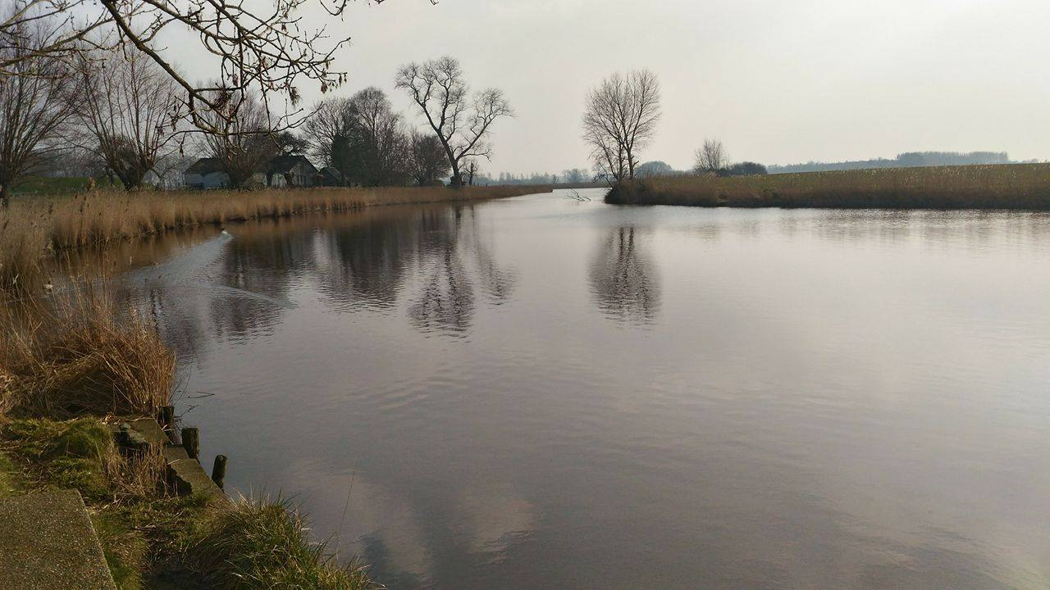

Author: Ayla Al-Nabhani and Hélen C. O. dos Reis.
Course: Water Management
Study year/semester: 2015-2016, semester 2.
HZ University of Applied Sciences.
Supervisor: T.A.D. Steenbakker and J.A.P van der Vleuten.
Vlissingen, the Netherlands
Version: 1.2
Ecological risk assessment of a possible connection of streams
An assessment of the potential ecological risks of connecting the WRWL to the Achterste Kreek, to realize the large water demand necessary for industrial processes of Dow Benelux.

Place of publication: Vlissingen, Netherlands.
Date: 22/06/2016
Student number: Alya Al-Nabhnai (67659) and Hélen C. O. dos Reis (72133).
Study year 2015-2016.
Semester 2.
Report type: Final Report
Supervisor: T.A.D. Steenbakker and J.A.P van der Vleuten.
Version: 1.3

Abstract
The aim of this research is to evaluate the possible risks to the Achterste Kreek after a connection with the WRWL (Westelijke Rijkswaterleiding) in the municipality of Terneuzen. This potential connection is due the fact that Dow Benelux is looking for areas to apply a constructed wetland near their industrial plant to be a pre-treatment for their water supply. The importance of evaluating the risks is regarding the Ecological Status (EHS) of the Achterste Kreek. Therefore, ecological and water quality data was necessary to evaluate the possible risks, the data was provided by M. Van Wingerden from the water board and it was from the year 2013 (the most recent data that the water board could provide us). In order to conclude if it will have an effect in the Kreek, water quality parameters were chosen such as Total Nitrogen, Total Phosphate, Dissolved Oxygen, Temperature, Transparency, pH and Chloride and to evaluate the ecological aspects, the Ecological Quality Ratio (EQR) was calculated for both areas. These parameters were chosen considering the three aspects that are related to the Ecological status of the Kreek according to the Index Natuur and Landschap: brackish water, the botanical grassland and the damp meadows. It is important to mention that a mass balance was calculated to predict the new water quality considering the parameters mentioned before, because, the most recommended is to calculate a water balance; however, no data regarding the discharge of the Achterste Kreek was found. Another important point to be considered was the water quantity of the Kreek, if the same was capable of receiving the new income from the WRWL, which will be a discharge of 500 m3/h. All this calculation were important to concluded if the connection will affect negatively the Kreek and also to support the final conclusion a multi criteria analysis (MCA) was used using some criteria considering the EHS status. In addition, experts and supervisors feedback was important to obtain a final conclusion. Finally, considering the water quality and ecological aspects it was possible to answer the main question of this research "Will the Acheterste Kreek's ecological status be negatively affected by connecting the WRWL to the Kreek?" and the conclusion was that the effect will most likely be neutral; however, it is important to consider some possible risks such as the concentrations of nitrogen and phosphate.

Introduction
Nowadays, the concern related to risks and impacts to the environment is increasing. Therefore, researches regarding this topic are important especially in case avoiding negative impacts to nature is possible. For this reason, the following research has aims to evaluate the impacts of connecting the Westelijke Rijkswaterleiding (WRWL) to the Achterste Kreek in the eastern Zeeuws-Vlaanderen area (municipality of Terneuzen). The importance of this evaluation is due the fact that this kreek has an Ecologische Hoofdstructuur Status (EHS); therefore, precautions are necessary in order to avoid any risk to the same.
An important aspect is the reason of connecting these areas; the company Dow Benelux is investigating places near their industrial plant to apply constructed wetlands in order to realize a pretreatment of their water sources to use and reuse for industrials and agricultural water use in the area. The WRWL is one of the water sources and it will be used after a pretreatment in the constructed wetlands in order to remove suspended solids. The wetland will mostly function as pretreatment for desalination, removing suspended solids and nutrients to some extent. The study area and the new stream in case of connecting the WRWL to the kreek are present in appendix 1 and 2 respectively.
Innovative technology such as this is becoming increasingly sought after due to changing climatic conditions, which threatens the availability of freshwater in the future and has already been in part responsible for drought in many regions of the world. Water security is a big problem globally and temperature and precipitation variation are expected to continue and intensify in the future . That is why reusing and recycling water supplies would help reduce pressure on water resources and why building constructed wetlands would help treat industrial water for reuse.
In order to evaluate potential risks in the Achterste kreek and produce an ecological risk assessment (ERA), a main research question and sub questions were formulated in the research proposal.
The main question is “Will the Achterste Kreek’s ecological status be negatively affected by connecting the WRWL to the Kreek?”
In addition, the subsidiary questions are:
- What is the Ecological status of the Kreek?
- What will the discharge from the WRWL be? Can the Kreek receive the incoming water quantity? If not, what are the impacts of this discharge for the Kreek?
- Will the water quality of the WRWL affect the ecology of the Achterste Kreek?
- According to the Legislation (Index Natuur and Landschap), what can be the scores of the water quality from the kreek and the WRWL?
- Which parameters of the WRWL water will bring the greatest risks to the ecology of the Achterste Kreek?
- Will the new water quality affect the EHS Status?
Therefore, to achieve the answers to these questions, the method suggested in the research proposal was followed, which was desk research combined with interviews with experts, using the multi criteria analysis to produce the ERA and visits to the area. To obtain the best evaluation, the “Index Natuur and Landschap”, which is a legislation that is related with the Ecologische Hoofdstructuur Status, and the “Referenties en Maatlatten voor Natuurlijke Watertypen Voor De Kaderrichtlijn Water 2015-2021”, which it is the water type references from the water board, are used to evaluate the water bodies. Therefore, the objective of this research is to realize an evaluation about the potential risks that can occur in the kreek due the connection of the WRWL.
At last, the following chapters are the extended theoretical framework, which provides the information, theories and analysis related to the topic of the research. Then the method, which explains how the results for this research was obtained. After that the results of the research, are presented and described, followed then by the discussion, where the results are explained and discussed, and then the conclusion with an answer to the main research question. Finally, the recommendation for the project moving forward is given.

Extend theoretical framework
The theoretical framework chapter provides the structure for theories, definitions and information related to the research topic. It is an important guide to this research because through previous studies and experiments it is possible to predict the outcome of this research and compare it to past theories.
The division of this chapter is into several sections including information on the project background, the legislation regarding the ecological aspects of the area, ecological importance, and the use of ecological risk assessment, previous projects and the possible consequences resulting from the proposed project in accordance to conducted research.

Project background
This project evaluated the potential risks and impacts of connecting the Westelijke Rijkswaterleiding (WRWL) to the Achterste Kreek in the eastern Zeeuws-Vlaanderen area (municipality of Terneuzen). The reason of this connection is that Dow Benelux BV is investigating the possibility of applying a constructed wetland as part of the project ‘Proeftuin Zoet Water E4’ to produce process water for industry. The wetland location will most likely be near their industrial plant in Terneuzen and it will serve as a pre-treatment (to remove suspended solids and some nutrients). The Dow Benelux is a company that creates innovative technology using scientific knowledge to find sustainable solutions for some of the world’s most pressing problems. They are active in the field to providing clean drinking water, renewable energy and improving agricultural productivity.
The future project consists in using a new water source, which is the discharge towards the Western Scheldt called ‘Westelijke Rijkswaterleiding’ (WRWL) to provide a discharge of around 450 m³/h. It is important to mention that this discharge will fluctuate during the year, for example, during the summer the discharge will be less than 450 m³/h. This is also important to the ‘free board’ limit instituted by the water board in order to avoid that the stream be complete dry. Then in this case, Dow will need others sources of water in order to avoid any problem to the wetland. The justification of using this water is because the same can be a new water source to the Dow Benelux Company; therefore, using it in the wetlands to meet water demand for industry and agriculture is a great investment. For example, due the fact that water scarcity is becoming more of a problem globally making technologies and projects such as this more needed to reduce the pressure on water resources and make recycling of surface and process water more common.
The proposed location of the constructed Wetland will be near the Achterste Kreek, which has ecological significance and thereby needs protection. The possibility of an ecological risk to this kreek due to the forced water stream from the WRWL must be investigated and assessed before continuing with the project.
Therefore, the importance of this research is regarding to the EHS-status of the kreek and according to the Index Natuur and Landschap the Achterste Kreek has Botanical Valuable Grassland (Agricultural nature type - A02.01.0, its water is classified as brackish water (Nature type - N04.03) and the vegetation Damp Meadows (Nature type - N10.02).
Finally, this research aims to assess the ecological risk and any impacts that risk can cause on the ecology of the Kreek.

Legislation background

Referenties en Maatlatten Voor Natuurlijke Watertypen Voor De Kaderrichtlijn Water 2015-2021:
In December 2000, Europe adopted the European Water Framework Directive (WFD) and one of the obligations of the WFD is to describe the environmental baseline. Therefore, references are the starting point for the ecological objective of natural surface water types. Several steps are needed to get the references to policy objectives of the current surface water bodies in the Netherlands. . The Referenties en Maatlatten Voor Natuurlijke Watertypen Voor De Kaderrichtlijn Water 2015-2021 is a new version that was improved and the improvements should be used for the purpose of distraction and state provision for second-generation River Basin Management (2015-2021).
This document has a global reference description of water type that gives a picture along with some pictures of the condition of the type in virtually undisturbed conditions. Therefore, this document is the updated version of the document Referenties en Maatlatten Voor Natuurlijke Watertypen Voor De Kaderrichtlijn Water, adopted in late 2012 by the Director Column.
In the case of this research, this document helped with information regarding the Brackish Water (M30) that it is the water type of the Achterste Kreek and the WRWL.

Natuur and Landschap Index:
In order to protect the kreek for any risk, the Natuur en Landschap Index is an important instrument for this research. This index is related to the National Ecological Network (Ecologische Hoofdstructuur status - EHS) of the Achterste Kreek. The EHS can be defined as a joint network of important existing and new nature areas. These areas can be used for agriculture associated to ecological nature management. The importance about this status is providing more nature areas that can be used for the animals and plants to obtain a large territory to spread out .
The purpose of the EHS according to the Index Natuur en Landschap is related to the improvement and maintenance of the nature/landscape quality in the Netherlands. Therefore, the Index Natuur en Landschap represents the possible areas that can have the EHS status also this index integrates the habitat types of Natura 2000, which is a network concerned about of rare and threatened species, and some rare natural habitat types, which are protected in their own right. It involves 28 EU countries, considering protection to species that habitats land and sea. The objective of it is to ensure the long-term survival of Europe's most valuable and threatened species and habitats . An important result of this index is that it is a widely recognized document; therefore, it ensures the best coordination between operators and governments. Another important result is that the index avoid differences interpretation related to the nature management objectives, therefore, making the process faster. This index describes the types of agricultural and natural landscape in the Netherlands and it is divided mainly in three components: Nature type, Landscape elements type and Agricultural nature type.

Ecological importance
As mentioned before, the EHS status is set to valuable nature areas and the Index Natuur en Landschap represents the possible areas that can have the EHS status also integrating the habitat types of Natura 2000. The objective of it is to ensure the life of precious and jeopardized species and habitats.
Therefore, a relevant aspect to this research is to why this kreek has this status. According to the Nature and Landscape Index, this kreek has the EHS status due the fact it has a several ecologically important values as mentioned before. The EHS Status is an important legislation to be followed regarding the Achterste Kreek; therefore, the following paragraphs are about the Botanical Valuable Grassland, Brackish Water and Damp Meadows.
In relation to the botanical valuable grassland, the importance of this ecologic type is due the fact that until the fifties were many rich grasslands (flowering), herbs and grasses. However, many of these grasslands depleted of species with the intensification in agriculture. Therefore, significant species characteristic have disappeared or reduced to marginal parts of the grassland, as in the ditch banks. In many counties conservation area planning was made in order to maintain or assist grasslands with a natural potential, develop existing herb-rich grassland.
Wet meadows occur on wet peat and clay soils and often have these species present; Rhinanthus, Lotus corniculantus, Lotus pedunculatus, Galium verum, Ranunculus acris and Caltha palustris. A micro gradient in moisture content is important and wet meadows along the rivers are considered internationally important, one species of significance is Fritillaria meleagris with a large proportion of its European population existing in the Netherlands . Another importance of damp meadows is that they are related to large transitions of vegetation and these elements are of importance for butterflies or scrub birds. Open landscapes may be of interest to grassland birds. Key areas with wet meadows are found in river valleys, high cultured salt marshes along (small) rivers and in the peatland area.
The water in both the WRWL and kreek is classified as brackish water, which often involves shallow and small water bodies; gully holes, ponds and salt marshes or seepage ditches behind the dike, but also old isolated landscape creeks. The soil can be both sand, peat and clay.
The salinity of brackish water can vary a lot, for example, fluctuations in chloride content may be large due evaporation in the summer. Chloride is fed by seepage or the wind (salt spray, which transports the inland salt from sea in finely dispersed droplets). Naturally, it takes the salinity of these waters in summer to evaporation and in winter take it off by a precipitation surplus. In these waters, the sulfate and phosphate levels are often high, but the nutrient concentrations may also vary under natural conditions. Therefore, these large variations results in only a few specialized plants and animals that can endure. An interesting point is that the vegetation in these waters is not limited by the phosphor but by nitrogen. .
Brackish water is important for some plants; Ruppia spiralis, Najas marina, Ranunculus baudotii, Zannichellia palustris, Zostera and Bolboschoenus maritimus. Algae are important: various types exist such as Enteromorpha intestinalis, Ulva lactuca, Rhodophyta (red algae), green filamentous algae and diatoms. .

Ecological risk assessment and its importance
A risk assessment is the process of identifying and evaluating potential threats that can result in a negative impact and consequently causing harm to others. Usually the process for risk assessment starts with identifying the hazard and after that, it is decided who can be harmed and how. Lastly, the risk is evaluated so precaution measures can be made. Risk Assessment is a useful tool that is often used in evaluating environmental conditions and threats to ecosystems. It helps facilitate decision making by quantifying risk or ranking it to determine the level of danger an ecosystem is facing. These way efforts can be spent on priority risk to minimize negative environmental impact. To measure a risk, it is given a rank of high, medium or low depending on the severity of the consequences and its probability .
An environmental risk assessment can deal with a variety of factors such as the survival of an endangered species or the biodiversity and productivity of a community in an ecological system. This assessment addresses human caused changes or disturbances that alter significant features of a system ranging from small streams to entire forests. When a new chemical, species or a change to the landscape is introduced, these actions may have consequences on the existing nature in the area. Assessing this kind of risk requires an analysis of the possible consequences and the likelihood of it being realized .
For this research, preferences need to be established between options in order to accomplish several objectives. Therefore, to accomplish these objectives measurable criteria can be established, usually the measurement is based in quantitative analysis such as scoring, ranking and weighting related to qualitative data. Then, it is possible to determine if the Achterste Kreek will suffer impacts or not, avoiding any risk to the area.

Examples of previous linking projects and their consequences

The “National River Linking Project” in India:
As mention before, the risk of connecting two water sources can be predicted for example by using ecological risk assessment that can compare the water analysis of both water sources and ecological and biological aspects. Therefore, analyzing previous projects regarding this subject can provide some information regarding research and projects that are concerned with potential impacts in the environment due to human projects. Therefore, the project “National River Linking Project” (NRLP) in India could be used as an example even it is a project with a large proportion compared to this research. In this project, the porpoise is to connect 37 rivers along India in order to supply others basins, which suffers with water deficit, therefore, providing water to all population. The NRLP, which it is an old project, is still in process of development due to economic and political issues. The scheme of the connecting can be seen in the figure 1.
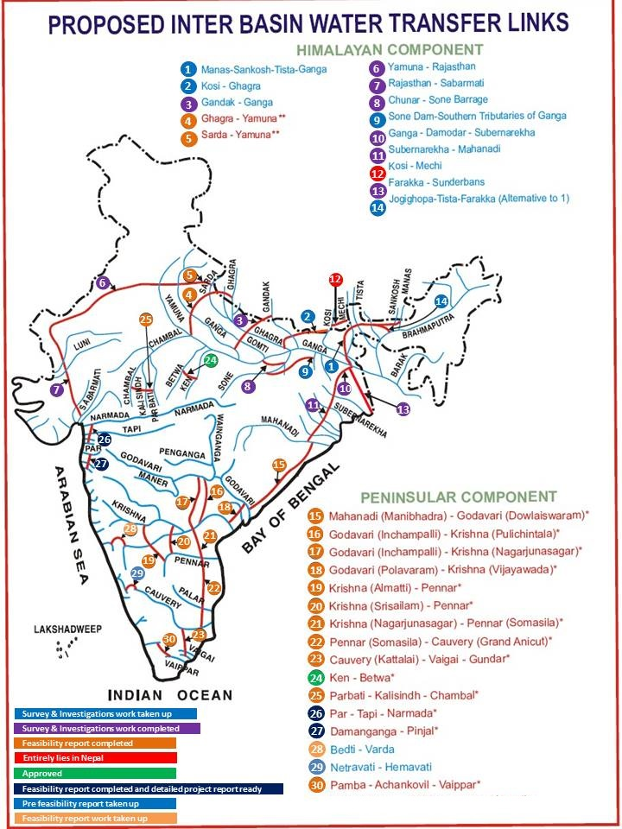
Figure 1- The River Linking Project in India in order to resolve water deficit supply.
Even the goal of the “National River Linking Project” is important to supply many regions; some organizations are concerned about the environmental impacts. Therefore, it is important to concern about some aspects, for example, the future impact in the environment (deforestation, soil erosion and water quality), social issues (rehabilitation) and political aspects. Therefore, this is an example of the importance of research regarding the potential environmental impacts also how to minimize some of the risks if the project will continue any way.

Case of the Rhine-Main-Danube in Germany:
Another important case of connecting water bodies, it is the case of the Main-Danube Canal. This canal runs from Main River, which is a Rhine River tributary, to Danube River, permitting traffic to flow between North Sea and the Black Sea as can be seen in figure 2.
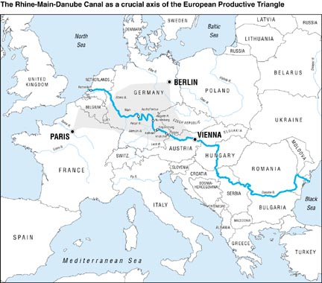
Figure 2 - The Rhine-Main-Danube Canal, which it flows from the North Sea until the Black Sea.
The history of this canal started in 793 due the wish of Charlemagne to open a route through the center of Europe for his battle fleet, however, heavy rains caused a collapse in the channel banks, and therefore, the project was abandoned. During the years, new projects appeared in order to create canal to connecting the water bodies such as the canal that existed in the Second World War, however, due the heavy damage during the war years resulted in another abandonment by the 1950´s. of the project.
However, after this period, the government realized that the canal would be a benefit for shipping, therefore, the plans for the canal connecting the two rivers became again and the Rhine-Main-Danube Canal was completed in 1992 and, then, the canal is a 3500 km waterway that runs through 15 countries.
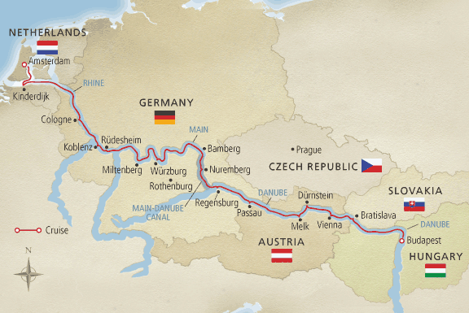
Figure 3 - Some countries that the canal runs in Europe, therefore, it knows as Europe Canal.
It is important to mention that the creation of the canal had some unexpected consequences such as several different marine species have spread from the Danube to the Main and vice-versa for the first time, therefore, changing the waterway ecosystem. In addition, it expects that the number of the invasive aquatic species is still increasing with several consequences for the ecosystem . According to, this type of biological invasions in waters take place in a hidden way, therefore, being difficulty to discover the invasive species just being able by reporting. Therefore, noticed that it is important the increase of research related to the possible risks and impacts of connecting streams in order to avoid or minimize the effects of a possible invasion in order to avoid that these species offspring to other areas.

Possible ecological consequences

-Water quantity effect on ecology
A risk of overflow is flooding that causes the addition of organic matter to the water. Through studies, it has been shown that one major flood caused the loss of 87% of the total loss of mass from the banks of the Carson River in Nevada. Even though organic matter is important for maintaining biological production, it can increase turbidity and sedimentation resulting in a reduction of primary production . Therefore, the capacity of the kreek is an important calculation in order to observe if the kreek has a volume capacity to the new water inflow. It is also important to mention that the discharge will not be all over the year, being fluctuate along the seasons.

-Water Quality (chemical parameters)
To evaluate the potential risks, it is important to narrow down some parameters that plays an important role in the aquatic life. Therefore, the following parameters were decided to be evaluate due the fact that the same it is important to permit basic life within aquatic systems.

Nutrients (Nitrogen and Phosphorus)
Nutrients are an important parameter to evaluate, especially Nitrogen and Phosphorus. This is due to the fact that they are essential to the living organisms (algae, plants, fishes) growth also survival especially in the aquatic ecosystems. Therefore, nutrients are essential to water bodies, however, in huge quantities can be harmful.

Phosphorus
Phosphorus is an important nutrient because it is necessary for plant growth and metabolic reactions in animals and plants, therefore, being a natural part of aquatic ecosystems. However, an increasing of it in water bodies can increase aquatic plant and algae growth. For example, the increase of algae initially increase dissolved oxygen (DO) via photosynthesis, however, after a while, the algae starts to die causing an increase of oxygen consumption by decomposing bacteria. This process will result in eutrophication, which affects all the aquatic system due the fact it decreases the DO then turning an aerobic environment into an anaerobic one also resulting in compounds with bad odor, tastes or even toxins. Therefore, poor water quality results in many unpleasant consequences.

Nitrogen
Nitrogen is also an essential nutrient in the aquatic environment because it is also related to growth of algae and aquatic plants that provide habitat and alimentation to others organisms, such as, fish, shellfish and others small organisms. However, high concentrations of nitrogen can be also harmful (it is also related to algal bloom that will result in eutrophication) then it can pollute many streams, rivers, coast waters and even the air and this result in environment, economic and social issues. Therefore, these nutrients were chosen in order to be analyzed in this research.
To demonstrate the impact of these nutrients, Waajen, Faassen & Lürling (2014) studied three ponds that were related to cyanobacterial blooms due the fact that this type of bloom affects the good water quality and pose serious risks for the population. The research occurred in the Dutch province of North Brabant and among 3,500 urban ponds, 125 showed cyanobacterial blooms in the period 2009–2012 . The health risk is due the fact that citizens may easily have contact with the water then can ingest cyanobacterial material during daily activities, particularly swimming. For them, to avoid the risk, monitoring of cyanobacteria and cyanobacterial toxins in urban ponds is a first step to control health risks. In order to avoid the blooms, it is necessary strategies that should focus on external sources of eutrophication and consider the effect of sediment P release and bioturbation (reworking of sediments) by fish.

Dissolved Oxygen
Another important parameter is the dissolved oxygen, which refers the level of free oxygen present in water, is one of the most important parameters related to water quality, because of its influence on the organisms living within a body of water. A dissolved oxygen level that is too high or too low can harm aquatic life and affect water quality. A relevant point is related that the amount of dissolved oxygen depends upon the species, the temperature of the water, pollutants present, and the state of the organism itself (adult or young, active or dormant) .
Dissolved oxygen (in mg/L) can also be influenced by temperature, pressure and salinity. The solubility of oxygen decreases as temperature increases. Second dissolved oxygen decreases exponentially as salt levels increase, because the ions from the dissolved salt attract the water molecules driving dissolved oxygen out of the polarized water. Third, dissolved oxygen will increase as atmospheric pressure increases, so water at lower altitudes can hold more DO.
If dissolved oxygen concentrations drop below a certain level, fish mortality rates will rise. In the ocean, coastal fish begin to avoid areas where DO is below 3.7 mg/L, with specific species abandoning an area completely when levels fall below 3.5 mg/L. Below 2.0 mg/L, invertebrates also leave and below 1 mg/L even benthic organisms show reduced growth and survival rates. . Therefore, the decrease of DO can seriously affects the aquatic life, for example, a dead zone can occur, which is an area of water with little to no dissolved oxygen present then no aquatic organism can live in an area like this, therefore, been nominated as dead zone.

pH
Other relevant parameter is pH and it is a determined value based on a defined scale, similar to temperature. This means that pH of water is not a physical parameter that can be measured as a concentration or in a quantity. Instead, it is a figure between 0 and 14 defining how acidic or basic a body of water is along a logarithmic scale. The lower the number, the more acidic the water is. The higher the number, the more basic it is.
The pH can be related to alkalinity that is a measurement of water’s ability to resist changes in pH. If a body of water has a high alkalinity, it can limit pH changes due to acid rain, pollution or other factors. The alkalinity of a stream or other body of water is increased by carbonate-rich soils (carbonates and bicarbonates) such as limestone, and decreased by sewage outflow and aerobic respiration .
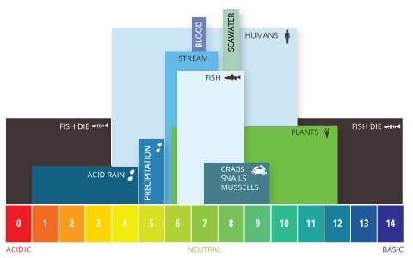
Figure 4 - Influence of pH in the aquatic system.
As can be seen in figure 4, the optimum pH levels for fish are from 6.5 to 9.0. Outside of optimum ranges, organisms can become stressed or die.
Even minor pH changes can have long-term effects. A slight change in the pH of water can increase the solubility of phosphorus and other nutrients – making them more accessible for plant growth. Therefore, the increase of nutrients will also increase the demand for dissolved oxygen. Then, all these processes will result in a eutrophic aquatic system. There are many factors that can affect pH in water, both natural and man-made. For example, most natural changes occur due to interactions with surrounding rock (particularly carbonate forms) and other materials. pH can also fluctuate with precipitation (especially acid rain) and wastewater or mining discharges.

Salinity
As a basic definition, salinity is the total concentration of all dissolved salts in water. Because salinity is related to ionic particles, the same is a strong contributor to conductivity. Salinity is not measured directly, but is instead derived from the conductivity measurement or values of chloride. Salinity measurements based on conductivity values are measured in ms/m and on chloride is mg/L.
Many different dissolved salts contribute to the salinity of water. The major ions in seawater (with a practical salinity of 35) are chloride, sodium, magnesium, sulfate, calcium, potassium, bicarbonate and bromine.

Temperature
Temperature affects both the chemical and biological characteristics of surface water. This is due the fact that the changes in temperature can affect the dissolved oxygen level in the water, photosynthesis of aquatic plants, metabolic rates of aquatic organisms, and the sensitivity of these organisms to pollution, parasites and disease. Therefore, temperature exerts a major influence on biological activity and growth.
Temperature is also important because of its influence on water chemistry. The rate of chemical reactions generally increases at higher temperature. Therefore, it is related to the dissolved-oxygen concentration in water, which is very important to all aquatic life. For example, lakes experience thermal stratification, a "turning" of its water layers when the seasons change. In summer, the top of the lake becomes warmer than the lower layers. However, in winter some lake surfaces can get very cold. When this happens, the surface water becomes more dense than the deeper water with a more constant year-round temperature (which is now warmer than the surface), and the lake "turns", when the colder surface water sinks to the lake bottom.
Other problems are related to thermal pollution, which it is the introduction of water that is warmer than the body of water into which it flows. It generally occurs near power plants. These industries discharge hot water that has been used to cool equipment directly into streams. Another source of thermal pollution is urban runoff. Warm water is less capable of holding dissolved oxygen. Low dissolved oxygen levels leave aquatic organisms in a weakened physical state and more susceptible to disease, parasites, and other pollutants.
Temperature is an important factor to consider when assessing water quality. In addition to its own effects, temperature influences several other parameters and can alter the physical and chemical properties of water. Water temperature affects metabolic rates and photosynthesis production, compound toxicity, dissolved oxygen and other dissolved gas concentrations, conductivity and salinity, pH and water density.
Being more specific, water temperature can affect the metabolic rates and biological activity of aquatic organisms. In addition to its effects on aquatic organisms, high water temperatures can increase the solubility and thus toxicity of certain compounds. These elements include heavy metals such as cadmium, zinc and lead as well as compounds like ammonia.
Finally, water temperature can be affected by many ambient conditions. These elements include sunlight/solar radiation, heat transfer from the atmosphere, stream confluence and turbidity. Human influences on water temperature include thermal pollution, runoff, deforestation and impoundments.

Transparency
Transparency can be defined as the light capacity to pass through a substance in an easy way. For example, it can mean the depth that the sunlight can penetrates through in a lake. The presence of light is related with the necessity of plants and algae to grow and to realize photosynthesis.
The water transparency depends on the amount of particles in the water. These particles can be algae or sediment from erosion, the more particles – the less the water transparency is, as can be seen in figure 5. In other words, when the water is murky or cloudy and contains a lot of particles, the light cannot penetrate as deeply into the water column.
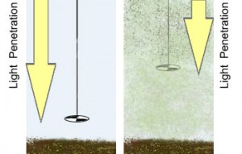
Figure 5 - The relationship between light penetration and Secchi depth.
This parameter is measured with a Secchi disk, which is a metal disk, about 20 cm in diameter that is lowered into the water on a cord as is illustrated in figure 5. The depth that the Secchi disk can no longer be seen through the water is the Secchi depth. When the water transparency is high, the Secchi depth is high. When the water transparency is low, the Secchi depth is lower.
Of course, it is normal for some rivers to have high levels of suspended solids, such as, the Black river in Brazil; however, it is natural to associate clear water with healthy water. Therefore, a change in the water clarity is an indication of pollution due the fact that an excessive increase of suspend solids can lead to an impaired water quality that can affect aquatic and human life.
For example, one of the problems related to low transparency is its effect on photosynthesis; low transparency can indicates the presence of a considerable amount of dissolved substances that can inhibit photosynthesis by blocking sunlight. Thereby, possibly affecting the entire aquatic system due the fact that without the needed sunlight, seaweed and bay grasses below the water’s surface will not be able to continue photosynthesis and may die. The death of these organisms will result in a sequence of events, starting with a decrease in photosynthetic processes, less oxygen is produced, thus further reducing DO levels in a body of water. The subsequent decomposition of the organic material can drop dissolved oxygen levels even lower. Second, seaweed and underwater plants are necessary food sources for many aquatic organisms. As they die off, the amount of vegetation available for other aquatic life to feed on is reduced. This can cause population declines higher up in the food chain .
The causes of decreased transparency can be related to erosion, pollutants (dissolved metals and pathogenic) and suspended solids and others.

Biological aspects
A disturbance is defined as “an event in time that is characterized by a severity, frequency and intensity that disturbs an ecosystem community or population and changes its resources or physical environment.” Disturbances to water systems can be caused by upstream ecosystems as they play a key role in diluting pollutants entering the downstream system by managing their impact on the ecosystem. If the water quality from the upstream system is good, it should support aquatic biodiversity .
Ecosystems integrate chemical and physical processes with biological interactions that collectively define how a system works. There are certain recognizable properties that distinguish a system; its productivity, range of energy sources and biodiversity. Small streams tend to provide a different habitat due to their physical, chemical and biological features that allow unique species to exist there. They offer shelter from flow extremes and predators as well as being a rich source of food for some species and offering spawning sites.
In this research, a possible risk can occur after connecting the WRWL and the kreek. Linking these water sources together may have some influence on the ecosystem integrity. Some of the possible consequences may include an altered flow regime, which may affect the physical habitat, which in turn has a major role in determining the biotic composition. The incoming water can have an influence on the downstream habitat by introducing new species, as movement will be possible when the two water systems are linked allowing migration of species. In addition, if the upstream water quality is extensively altered it could lower productivity there by affecting the communities that utilize the resources in the downstream system.

Method
The methodology of this research is essential to obtain the most reliable information and consequently answer the main question of the research. Therefore, this chapter explains the method and steps to obtaining the results of this research.

Water quality and Ecological Data:
The data regarding the water quality and ecological aspects were obtained from M. van Wingerden from the water board. This data was essential to evaluate some parameters such as total nitrogen, total phosphate, chloride, pH, temperature, transparency and to calculate the EQR (ecological quality ratio). The data given is from the year 2013, which is the most recent data available with the water board. In addition, the research supervisor T.A.D Steenbakker also provided data regarding the water quality, which was important to be a comparison with the water board data.
The ecological data provided information regarding important species of macro-fauna, Phytoplankton and Macrophytes that are present in the kreek and in the WRWL. These species were important to verify the relation with one of the kreek EHS status to establish which biological species are in risk. This was an important point to look through the species list and research their preferred conditions for survival. For example, the theoretical background mentions species that are specific to brackish water and require a certain chloride concentration so cross-referencing these species with the Achterste kreek’s list of species to find matches.

The Ecological Quality Ratio (EQR):
The EQR calculation is used to quantify ecological quality of water bodies and assign the water bodies an ecological class based on biological indicators. This would give a clear indication of the ecological quality of the two water bodies and would make it easier to compare that aspect, therefore, the reason of using this calculation to analyze the ecological aspects of both streams.
This calculation uses the species composition and abundance to describe the ecological status of a water body based on macro fauna. The species are classified into the typical dominant, negative and positive taxa. These species are indicators of the ecological status of water. Negative dominant species are species who, when present in large numbers, indicate a poor ecological status. Positive dominant species can occur dominantly in the reference situation.
To calculate the ecological quality ratio three main parameters are calculated;
-DN % (abundance): the percentage of individuals belonging to the dominant negative indicators based on abundance classes;
-KM % (number of taxa): the percentage of characteristic taxa;
-KM % -DP +% (abundance): the percentage of individuals belonging to the characteristic and dominant positive indicators based on abundance classes.
Then finally, the formula used for the calculation is:

The European Water Framework Directive (WFD) requires that all European waterbodies are assigned to one of five ecological classes, the EQR calculation gives a number between 0 and 1 and those are divided into five classes as can be seen in table 1.
Table 1- Ecological quality classes in relation to EQR value
Ecological quality | EQR value
High | 0.8- 1.0
Good | 0.6- 0.8
Moderate | 0.4- 0.6
Poor | 0.2- 0.4
Bad | 0.0-0.2

Water quality
In order to analyze the water quality, tables and graphs were made regarding the following parameters: total nitrogen, total phosphate, pH, oxygen, chloride, temperature and transparency using Microsoft Excel for both water bodies. The reason for choosing these parameters is because they have a great influence on aquatic ecology and their importance in this research which was explained in chapter 2.

Achterste Kreek
The data from the water board was used to calculate the kreek water quality; the average of each parameter was based on six values along the period of February 2013 until December 2013.

WRWL
The data from the water board was used to calculate the WRWL water quality; the average of each parameter was based on twelve values along the period of January 2013 until December 2013. In addition, the data from the research supervisor T.A.D Steenbakker was used in order to have an overview of the water quality of this water body, this data is an average of a long period of 2008 until 2015.

Prediction of the new water quality
A new water quality is necessary to predict any risk to the EHS status of the kreek. Therefore, a predication was made by comparing the values of each parameter of both areas. After that, the predicted water quality was compared with the values of brackish water chemistry that are present in the Index Natuur and Landschap. It is important to mention that the best way to predict a new water quality should be doing a water balance; however, it does not exist any data from the discharge of the kreek. Therefore, it is not possible to calculate the water balance.

Water quantity calculation
Another important aspect is regarding the volume of the kreek, if the same is able to handle the amount of the WRWL after the connection. Therefore, an estimation of the kreek volume was made. The calculation was based on the estimation of the surface water area of the kreek from the discharge point from the WRWL using AutoCAD with the value of the average water depth provided from the data of the water board (February 2013 -December 2013).

Risk Assessment
A multi criteria analysis (MCA) method is used to analyses the results, making it easier to compare the different criteria in the research for each system and to make a conclusion. The MCA can also be used to support the conclusion. This method is used to structure and solve problems involving multiple criteria and that is why it was chosen and used in for this research.
In order to performance the best MCA, it is necessary to establishes criteria and prepare important weights also the contribution of each criterion in order to accomplish the objectives. Therefore, to perform the risk assessment, measurable criteria were established usually based on quantitative analysis such as scoring, ranking and weighting related to qualitative data.
A table is created where each criteria is given a + or –for each system. The result of this would be an end score for the WRWL, the Achterste kreek and the system after connection. The end scores could be;
++ = very good
+ = good
0 = netural
- = bad
--= very bad
This allows easy comparison between systems, as the end scores can be compared to see if the kreek’s new state will differ greatly from its original state after the connection is made.

Quality assurance
Along with weekly meeting with minor research supervisors and contact with two aquatic ecologists (M. van Wingerden from the water board and J. Heringa – professor at Hz) was important to obtain an expert opinion regarding the linking of the two water bodies to have the most reliable discussion and conclusion regarding the possible risks to the kreek. Their feedback on the research and their expert opinion would insure that the research is of a good quality.

Final conclusion and recommendations for the project moving forward
To make the conclusion, the results, the MCA and the discussion will be considered to make a conclusion and answer the main research question; will the Achterste Kreek’s ecological status be negatively affected by connecting the WRWL to the Kreek?

Results
The following topics are covered in this chapter: the important ecological aspects of the Achterste Kreek that are necessary to the Ecological Quality Ratio (EQR) calculation; the results in graphs of the water quality (chemical parameters, such as Total Nitrogen, Total Phosphate and Chloride) of the Achterste Kreek and WRWL and the capacity of the kreek (water quantity part). In addition, the EQR results, a comparison of the chemical quality of the two water bodies as well as a comparison against the legislation. These results are used to identify the potential risk to the kreek in case of the connection.

Achterste Kreek Water Quality parameters and Ecological aspects
The following topics is regarding the ecological and the water quality aspects of the kreek.

Ecological Aspects
The Achterste kreek has recorded over 160 invertebrate species and 19 macrophytes species collectively since 2004. Plants such as Zannichellia palustris and Bolboschoenus maritimus exist in the Achterste Kreek and are specialised plants that can endure the variation in salinity of brackish water and their survival is usually limited by nitrogen content. Some of the algae species found in the Kreek include Enteromorpha and Chlorophyta (green algae division).
In relation to this topic, the calculation of the Ecological Quality Ratio (EQR) was made using the document Referenties en Maatlatten Voor Natuurlijke Watertypen Voor De Kaderrichtlijn Water 2015-2021 ('STOWA’) for the M30 (brackish water) water type. M. van Wingerden from the water board provided the files regarding with the species of macro fauna, phytoplankton and macrophytes and they are presented in the appendix 3.

Ecological Quality Ratio - EQR:
As mentioned before, the EQR calculation was made and following table was used to score it.
Table 2 – Ecological quality indicated by range of EQR values
Ecological quality | EQR value
High | 0.8- 1.0
Good | 0.6- 0.8
Moderate | 0.4- 0.6
Poor | 0.2- 0.4
Bad | 0.0 0.2
The Kreek has an EQR value equal to 0.61 and the WRWL has the EQR value of 0.55. The List of species and full calculation are available in appendix 4.

Water Quality
Regarding the water quality parameters, the following were chosen: total nitrogen, total phosphate, dissolved oxygen, pH, chloride, temperature and transparency. All the values necessary to the calculation of the average of each parameter are presented in appendix 5 and the importance of each parameter is presented in chapter 2 (Extended Theoretical Background).
Table 3 - Values of certain parameters regarding the water quality of the Achterste Kreek in the period of February-2013 until December-2013.

Capacity of the kreek
Another important aspect of this research is about the quantity, because, it is important to predict the possible effect of the WRWL discharge into the kreek, if the water quantity of the WRWL can affect the ecology of the kreek. Table 4 presents important discharges related to the WRWL.
Table 4 - Important discharges regarding the connection of the WRWL and the kreek.
Important Discharges
WRWL average | 988 m³/h
Discharge required - DOW | 450 m³/h
Discharge WRWL to Kreek | 500-600 m³/h

The volume of the kreek was calculated using the data provided from the water board and AutoCAD. Figure 6 outlines the entirety of the kreek.
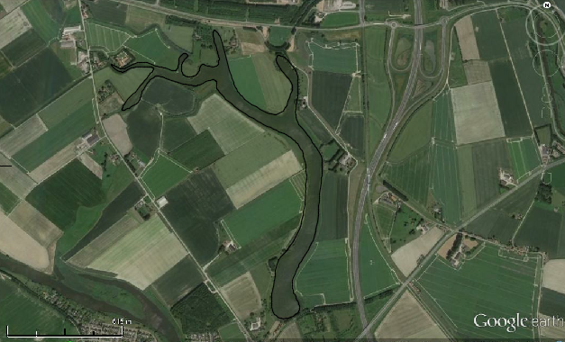
Figure 6 - Achterste kreek surface water in order to estimate the surface water area in AutoCad.
Table 5 is the volume prediction of the Achterste Kreek; however, the discharge of the WRWL will occur in a determined location as can be seen in the figure 7.
Table 5 - Volume (m³) estimation of the Achterste kreek.
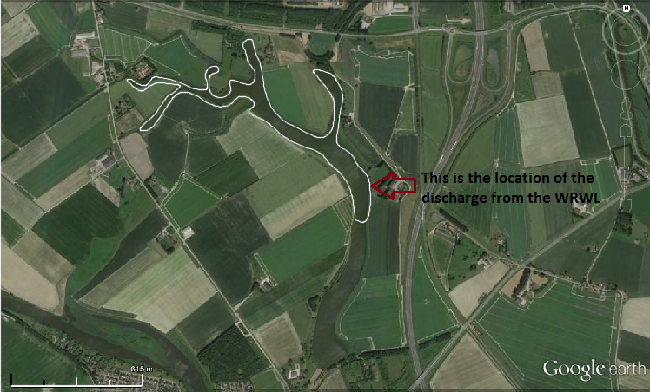
Figure 7 - Part of Achterste kreek surface water related to the location of the discharge from the WRWL.
Therefore, a new volume prediction was calculated in order to obtain the most realistic situation due the fact that the water from this area flow from the down to up as can be seen in figure 8; therefore, the full area should not be considered.
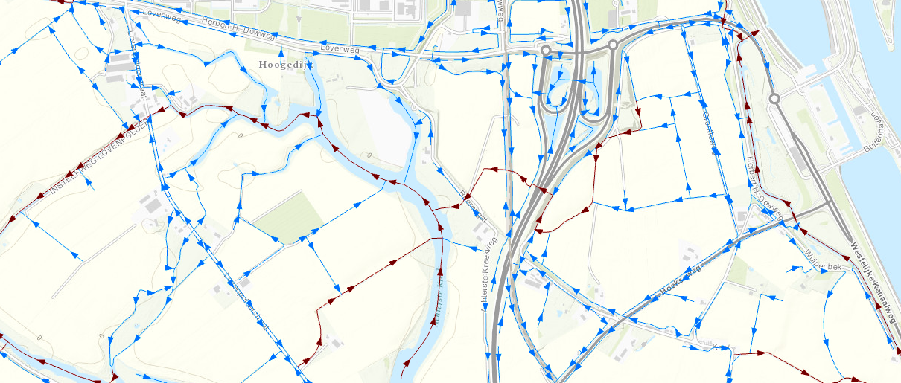
Figure 8 – Flow of the stream.

The new volume is presented in table 5.
Table 5 - New volume (m³) estimation of the Achterste Kreek.

WRWL water quality aspects
The following tables are related to the WRWL water quality for some specific parameters: total nitrogen, total phosphate, dissolved Oxygen, pH, conductivity, temperature and transparency. The table 7 is regarding the data provided by the research supervisor T.A.D Steenbakker and table 8 is the data provided by M. van Wingerden from the water board, which all the data is presented in Appendix 6. Other important information provided by M. van Wingerden are the files regarding with the species of macro fauna, phytoplankton and macrophytes and the same are presented in the Appendix 7.
Table 7 - Values of certain parameters regarding the water quality of the WRWL in the period of January 2008 until May 2015.
Table 8 - Values of certain parameters regarding the water quality of the WRWL in the period of January-2013 until December-2013.

The prediction of new water quality
In order to evaluate the possible impacts of the connection, the values of the parameters already mentioned will be compared in the form of graphs to make it possible to predict a new water quality and then compare that with the legislation.

Total Nitrogen:

Figure 9 – Nitrogen values of the WRWL and the kreek.
As can be seen in figure 9, the total nitrogen levels fluctuate over the year for both water systems, but it is clear that the WRWL has a higher dissolved Nitrogen level compared to the Achterste Kreek. The Kreek’s levels fluctuate between 2-5 mg/L while the WRWL are mostly between 6-8 mg/L with a drop in concentration around June of that year.

Total phosphate:

Figure 10 – Total phosphate values of the WRWL and the kreek.
As is seen in figure 10 above, the trend for phosphate levels is a gradual rise from December until the end of August where a sharp fall in phosphate concentration is observed. Both water systems follow the same trend with some differences in concentration. The WRWL phosphate concentration fluctuates more often from the beginning of the year until mid-June, while the kreek’s phosphate level gradually rises until June where a steep rise in concentration is observed.

Oxygen:

Figure 11 – Oxygen values of the WRWL and the kreek.
The DO concentration in the Kreek is generally a little higher than that of the WRWL (figure 11). The WRWL has an average of 6.6 mg/L of DO to an average of 9.1 mg/L for the kreek.

pH:

Figure 12 – pH values of the WRWL and the kreek.
As is shown in the figure 12, the pH of the WRWL is generally more acidic than that of the kreek. The WRWL’s pH peaks around September of that year to reach 8.5 by the end of the year both the kreek and WRWL pH drops.

Chloride:

Figure 13 – Chloride values of the WRWL and the kreek.
Figure 13 shows that there are slight differences between the chloride concentrations during that year between the two water bodies considering the summer time. Other than that, the values are similar with slight variations. Brackish water with concentration less than 200mg/L is considered to be of bad quality according to the index Natuur and Landschap; the lowest concentration recorded was for the WRWL with concentration 330 mg/L.

Temperature:

Figure 14 - Temperature values of the WRWL and the kreek.
The WRWL is generally warmer than the Achterste kreek however, the water temperature does not differ that greatly between the two water bodies (figure 14).

Transparency

Figure 15 - Transparency values of the WRWL and the kreek.
In figure 15, the transparency values, found using the Secchi Disk method, for both the WRWL and the Achterste kreek are plotted. The transparency of the WRWL varies throughout the year between a maximum of 60 cm and a minimum of 20 cm. The Kreek’s transparency gradually decreases from January until October where it has a value of 10cm, then rising the next month to 40 cm. It is important to keep in mind that the larger the transparency value, the clearer the water.

Comparison between the water quality predicted after the connection with the Index and STOWA
After comparing the water quality of both area between them, now, the comparison is of the global idea of the new water with the legislation against the values present in the Index Natuur and Landschap (table 9) and the STOWA (table 10) in order to have no risk to the ecological status of the kreek:

Index Natuur and Landschap – Brackish Water:
Table 9 - Values of chemical parameters and transparency according the Index Natuur and Landschap - Brackish water.
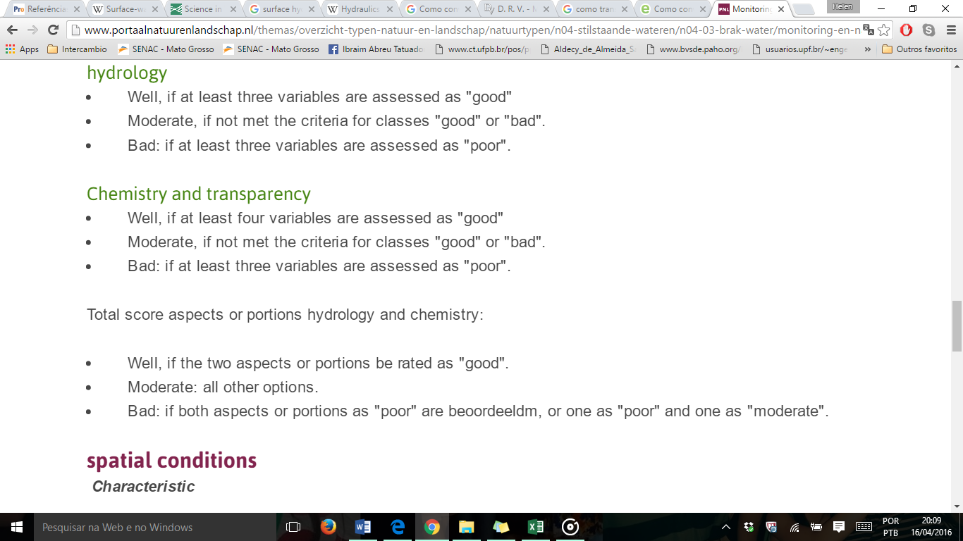
Figure 16 - Water quality confirmation also regarding the Index Natuur and Landschap - Brackish water.
Using the Index Natuur and Landschap yardstick (table 9) chemical quality elements of a Brackish Water type. As can be seen, depending on the value or range the parameter is, it can be deduced whether the water chemistry is of a good, moderate or bad quality.

Chloride
The values will be below 2800 mg/L and above 300 mg/L.

pH
In the case of pH, it can predicted that the levels of it will be around 7.4 – 9.

Nitrogen
Considering the new water quality will be around a value of 2-8 mg/L.

Total Phosphate
In the case of total phosphate, both water systems follow the same trend with slight differences in concentration. The values will fluctuate between 0.5 – 2.5 mg/L.

Transparency
Considering the transparency, it can infer that the values will fluctuate around 10 – 60 cm.

STOWA – Brackish Water (M30):
Table 10 - Values of chemical parameters and transparency according to STOWA – M30 water type.
Using the ‘STOWA’ yardstick (table 10) chemical quality elements of an M30 – water type. As can be seen, depending on the value or range the parameter is, it can be deduced whether the water chemistry is of a very good, good, moderate, inadequate or bad quality. It can see that the values are very alike between the Index and the STOWA; however, table 10 has more parameters to be evaluated such as temperature and oxygen (saturation).

-Temperature
The values of temperature will to be around 4 °C to 20 °C.

-Oxygen
In the case of this parameter, it will fluctuate with a low saturation of 40% and probably exceed a concentration of 100 %.

Risk Assessment (MCA)
The table below assesses the criteria chosen by attaching a weight to each criterion and rating it.
The list of criteria chosen is:
- EQR value
- Transparency
- Chloride concentration
- Nitrogen concentration
- Phosphorous concentration

Aspects | Weight | Parameters | WRWL | Achterste kreek | After connection
Ecology |  | EQR (calculation) | + | ++ | +
Chemistry (According to brackish water legislation) |  | Chloride | ++ | ++ | ++
 |  | Nitrogen | -- | - | -
 |  | Phosphorous | -- | -- | --
 |  | Transparency | - | -- | -
End score |  |  | -- | - | -

++ = very good
+ = good
0 = neutral
- = bad
-- = very bad

Discussion
In this chapter, the information presented in the results chapter will be discussed in order to obtain a clear understanding of the results such as the explanation regarding the values of the Ecological Quality Ratio (EQR), the water quality (chemical parameters) of both water streams and capacity of the kreek.

Water quality

-Ecological quality
The EQR for both water systems was calculated to give an indication of the ecological quality of water. This calculation indicated the ecological quality in relation to the macro-fauna that exist in the water system, as they can be indicators of the chemical water quality. This qualitative method of assessing the water quality was used for both the WRWL and the Achterste kreek, with the kreek scoring 0.61 and the WRWL scoring 0.55. Therefore, it is deducted that the kreek has a better ecological quality falling into the ‘good’ range while the WRWL falls into the ‘moderate’ water quality range.
Any EQR above ‘moderate’ is passable with the Water Framework Directive (WFD). While doing this calculation a list of all the macro-fauna species for both water systems were studied, in which it can be noticed that both water systems share a number of the same species. This indicates that both the water bodies are able to sustain these species hinting at a similar ecological structure.

-Achterste Kreek and WRWL water quality
As mentioned before some chemical and physical parameters were chosen in order to evaluate the water quality of both water bodies. Therefore, the following subtopics are the discussion regarding important nutrients (total nitrogen and total phosphate), dissolved oxygen, pH, chloride, temperature and transparency.

–Total Nitrogen
As mentioned before, the levels of the Achterste kreek fluctuate between 2-5 mg/L, with a general trend of decreasing around in the summer period most likely due to a absorption of dissolved nitrogen for growth. The values presented by this parameter are higher than the expected from a ‘good’ range of water quality according to STOWA and the Index Natuur and Landschap; being considered with a ‘bad’ range quality considering the average and the minimum value as moderate. Therefore, even without a connection between the two water bodies, this parameter is already considered to be in the ‘bad’ range of values.
The concern regarding this is possible impact in the ecosystems presents in the kreek. For example, the Cyanocatena imperfecta is type of blue-green algae that exists in the Achterste Kreek and its growth is strongly related to the nutrient concentrations in water such as Nitrogen. High concentration of nitrogen combined with other conditions can lead to algal blooms. In addition, plants such as Zannichellia palustris and Bolboschoenus maritimus exist in the Achterste Kreek and are specialised plants and their survival is usually limited by nitrogen content.
In the case of nitrogen in the WRWL, the average is around 50% higher than the values in the kreek. Therefore, it can infer that after connection the values are going to be higher than the good values considered in the Index and as mentioned before, high concentrations of nitrogen, can results in an algae bloom.

-Total Phosphate
Although the phosphorous concentration of the WRWL is very close to kreek’s concentration in the second half of the year, there is a big gap in levels from January to June. Lowest concentration recorded for the kreek is 0.24 mg/L and the highest was 2.4mg/L, both values fall into the ‘bad’ water quality range. From this and the nitrogen results, it can be inferred that the kreek’s water quality to begin with, is not classified as ‘good’ according to Index Natuur and Landschap neither with the STOWA.
The same situation occurs in the WRWL, the minimum concentration is 0.37 mg/L and the highest is 2.7 mg/L. Therefore, high concentrations of this parameter and nitrogen can results in some problems, such as eutrophication.

-Dissolved Oxygen
The dissolved oxygen (DO) concentration in water is an important parameter since it allows life. All plant species and aquatic organisms need a certain concentration of oxygen for their survival. The DO average concentration in the kreek and the WRWL is 10.9 mg/L and 6.62 mg/L respectively. In addition, considering the values of the oxygen saturation, the values of it to the kreek is ranged as ‘very good’ and to the WRWL is ‘good’ according with the values of the STOWA. According to the theoretical background, most aquatic organisms such as fish prefer a DO level of to 3.7 mg/L . Therefore, it can infer that the concentration of dissolved oxygen in both streams will not infer in any risk to the EHS status of the kreek.
From the high levels of dissolved Oxygen in the kreek it can also be seen that the kreek did not go through eutrophication that year, as eutrophication usually causes oxygen deprivation in the water system.

-pH
As mentioned in the chapter 2, the optimum pH levels for fish are from 6.5 to 9.0. Outside of optimum ranges, organisms can become stressed or die. The pH of the kreek is generally more alkaline, with an average pH of 8.3 and the WRWL an average of 7.85. Therefore, this parameter is classified as “good” according the Index Natuur and Landschap and ‘very good’ according to the STOWA considering both water streams.

-Chloride
Chloride is directly related to the concentration of salts dissolved in the water. There are slight differences between the chloride concentrations around the summer period during that year. The average chloride concentration for the Kreek is higher than it is in the WRWL by 631.7 mg/L. This indicates that the chloride concentration of the water after linking the two water bodies will lower as the kreek’s chloride concentration will be slightly diluted.
The drop noticed (figure 13) for the WRWL Chloride concentration, may have been the cause of heavy rainfall before measuring the data which would cause the concentration to be greatly diluted. As for the higher peaks in concentration are likely caused by evaporation or seepage.
Brackish water with concentration less than 200mg/L is considered to be of bad range according to the index Natuur and Landschap, not being considered as a brackish water any more, the lowest concentration recorded for the kreek was 740 mg/L. In addition, the maximum concentration should be less than 10000 mg/L and in the kreek, the maximum concentration was 2800 mg/L. Therefore, it can infer that this parameter presents a ‘good’ water quality range.
The WRWL can also be classified as ‘good’, because the concentrations are between 330 mg/L and 2100 mg/L. Even considering the values presented in the STOWA, both water streams are considered with very good water quality range to this parameter.

-Temperature
Water temperature is important as it can affect other parameters thereby affecting the ecology. Dissolved oxygen is concentration is dependent on water temperature and salinity. The range of temperature between the two water bodies is similar so it should not be an issue if they were linked. According to STOWA values, both water streams presents ‘very good’ values; therefore; this parameter will not consists in any risk to the ecological value of the kreek.

–Transparency
From the graph (figure 15), it can be seen that the WRWL has higher transparency than the kreek. The transparency indicates the water quality as the concentration of dissolved substances and phytoplankton can affect the water clarity. The WRWL has an average transparency of 40.83 cm, while the kreek has an average transparency of 26.67 cm. The reason why the WRWL might have a greater transparency value is that there is more flow in the system.

Water quantity
Considering that the discharge from the WRWL will be around 450 m³/h and the volume of the kreek is around 170 000 m³ (considering the point of the WRWL discharge), the new discharge will not cause any side effect.
Even with a discharge of 24 hours, the discharge is going to be 12000 m³ and this volume is around 7% of the total volume of the kreek. Therefore, it is a small quantity compare with the total volume.
DOW requires a discharge of 450 m³/h for 24 hours a day to maintain the wetlands. However, that number is dependent of the availability of water, as 33% of the year that quantity will not be met from the WRWL alone so an additional source might be needed. The wetland will have to deal with a shortage of water at some periods during the year, such as the summer period. In addition, the flow from the WRWL will have to be stopped when it reaches a certain NAP level depending on the “peilbesluit”.

New water quality
Because there is no available data for measurements of the kreek’s discharge, causing it be unknown, it is not possible to make a balance and calculate the nutrient load of substances to give a specific prediction to the future water quality. Therefore, in order to predict a possible risk to the kreek, a range for the maximum and minimum value for the new water quality was estimated by comparing the results. After discussing the water quality of both area between them, now, the comparison is of the global idea of the new water with the legislation of the Index Natuur and Landschap (table 9) and STOWA (table 10) in order to have no risk to the ecological status of the kreek:

-Nitrogen
Estimating the new water quality will be around a value of 2-8 mg/L, it can be inferred that the quality range is ‘bad’ regarding the values in the Index Natuur and Landschap and the STOWA. However, as mentioned before, analyzing the separate values for both areas; it can be predicted that the water quality range of both areas is considered ‘bad’. Therefore, making a conclusion regarding this parameter is a delicate subject, because, even without a connection, the results currently present fall within the ‘bad’ classification.

-Total Phosphate
In the case of total phosphate, both water systems follow the same trend with slight differences in concentration. The values fluctuate between 0.5 – 2.5 mg/L, therefore, it can be inferred that the quality for this parameter is also ‘bad’.

-pH
In the case of pH, it can estimated that the levels of it will be around 7.4 – 9; therefore, it is within the ‘good’ water quality classification for a brackish water type.

-Chloride
It is possible to conclude that both areas present good values for this parameter since the values will be below than 2800 mg/L and above than 300 mg/L, since anything below 300mg/L is not considered brackish anymore. Therefore, it can be inferred that after a connection, this parameter will not be a problem.

–Transparency
The kreek has an average depth of 1.35 m, and the highest transparency is 0.4m. Considering the values presented in the STOWA (table 9), the estimated values for this parameter fall within the ‘inadequate’ classification. When the WRWL is linked to the kreek, more flow and movement of water in the kreek is expected. This could either, improve the transparency of the kreek (due the fact that the transparency in the WRWL is higher) thereby allowing a higher percentage of light transmission into the water or cause turbulence and then provoking a disturbance in the bottom of the kreek and as a result an improvement of sediments and then decreasing the transparency. Considering the values in the legislation, this parameter is ranged as bad quality for both streams.
Considering the five parameters pH, Chloride, Transparency, Total Nitrogen and Total Phosphate three of them are considered ‘bad’ and the rest ‘good’ range. Considering the figure 16 in results chapter, it can be inferred that the quality is poor. However, considering also the temperature and the dissolved oxygen, it can infer that in total are four parameters with ‘good’ range instead of just two. Therefore, considering from seven parameters, four parameters present a good range and three with bad (total nitrogen, total phosphate and transparency).

Greatest risks to Achterste Kreek
Considering the values present in the Index Natuur and Landschap, the nitrogen can be the most harmful parameter to the status of the kreek due the fact that the concentration of the same after a connection will be around 2-8 mg/L. In addition, as presented in the table 9 (results chapter), the best value will be less than 1.8 mg/L. A high concentration of nutrients increases aquatic plant and algal growth, and might results in algal blooms and thereby eutrophication.
Another point to this risk is that the concentration of total phosphate is also ranged as ‘bad’ and in combination with the high values of nitrogen can lead to an algal bloom and eutrophication, in turn causing aquatic life to become stressed or die thereby endangering the ecological status of the kreek. However, it is important to consider that after the connection, the aquatic system will find an equilibrium for each parameter considering the volume of both areas, then considering that the volume of the kreek is higher than the discharge, a possible dilution will happen for the new volume coming from the discharge.

Risk Assessment
The MCA table in the results chapter establishes the quality of the water systems and compares them with each other and the system after the connection. The table also serves as a support for the conclusion. As can be seen, the WRWL had a ‘very bad’ score for its current state, while the kreek had a ‘bad’ state. After the connection, the state for the kreek is still the same overall. The MCA might be considered subjective, however, the reason for using it was to create a visualization of the results and discussion.

Conclusion

The Achterste kreek and the WRWL are quite similar considering the ecological and water quality. Therefore, the main research question ‘Will the Achterste kreek’s ecological status be negatively affected by connecting the WRWL to the kreek?’ can be answered with it will not be negatively affected. It is more likely to have a neutral effect, as the two water bodies are quite similar with just some slight differences between total nitrogen and total phosphate concentrations. However, it is important to mention that even without the connection, the values of nitrogen in the kreek is already ranged as bad quality and even with this range, the EQR shows a good range for good water quality. Therefore, it can be deducted that the ecological water system is not affected with these nitrogen values and it is very likely that after the connection, the situation will continue to be the same way (no impact from nitrogen in the aquatic life). In addition, as mentioned before, after a connection the two water streams are mixed, the new water quality will become the weighted average of the kreek and WRWL as an equilibrium between the parameters values and the volume of each water system and this statement is based on the opinion of the expert J. Heringa (an Aquatic Ecologist professor at Hz).

Recommendation
It is recommended that the project continue as is. One recommendation would be to calculate the discharge of the Kreek to then calculate the mass balance allowing the calculation of a more precise figures for weighted averages of the chemical parameters.
The only possible major risk in this situation is with the nitrogen concentration; therefore, some actions could be taken in order to avoid any risk regarding this parameter. A small action could be to supervise the surrounding areas in order to avoid any excess nitrogen from sources such as runoff from agriculture (fertilizes). Considering agriculture, some actions could be nutrient management (using the proper amount of fertilizers), cover crops or buffers (plating trees or grasses that can absorb or filter this nutrient) . Another contribution will be advice people to avoid their pets to defecate in the surrounding area of the WRWL and the kreek with some warning signs in order to avoid pets’ waste, which in a considerable amount have high concentrations of nutrients. These are can be some preventative measures to avoid increasing the current nutrient concentrations.

Appendix

Appendix 1: Localization of the Achterste Kreek and the WRWL
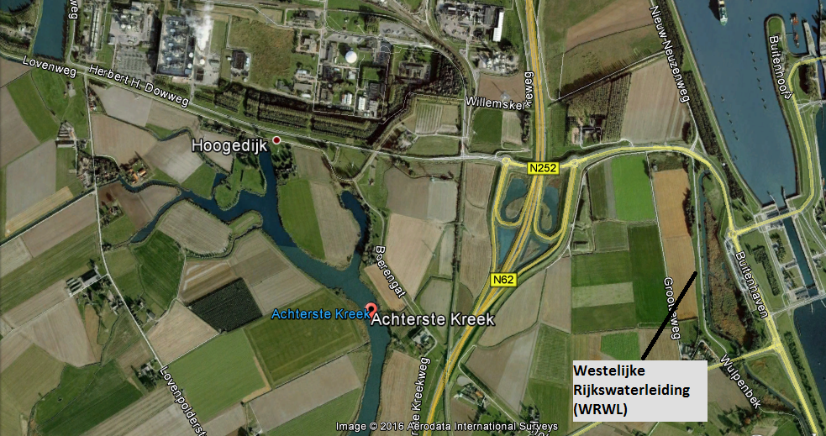
Figure 17 – Localization of the study area in the municipality of Terneuzen.

Appendix 2: The possible connection from the WRWL to the Achterste kreek.
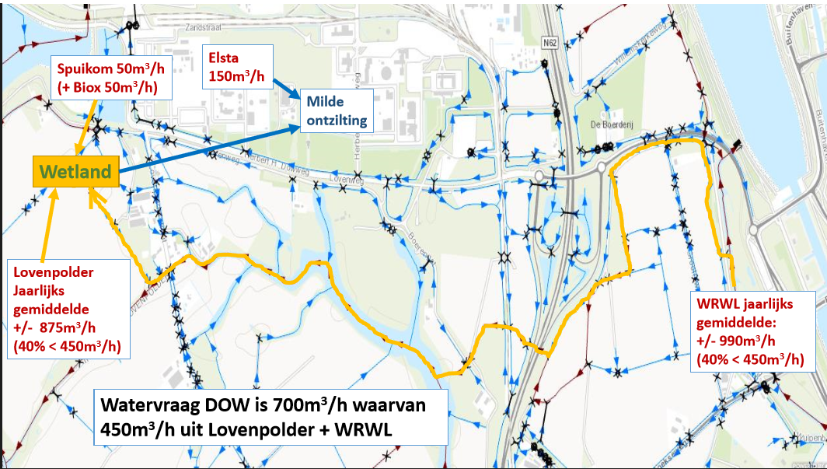
Figure 18 - Map regarding the future stream in case of connecting the WRWL to the Achterste Kreek.

Appendix 3: Tables about the ecological aspects of the Achterste Kreek
- Macrofauna:

- Phytoplankton:

- Macrophytes:

Appendix 4: EQR calculation
- Kreek EQR
The macro-fauna species data is from the year 2013
Taxon | Found | M30 | Abundance Classes
Chironomus annularius agg. | 14 |  | 4
Chironomus luridus agg. | 21 |  | 4
Gammarus duebeni | 191 | P | 6
Gammarus tigrinus | 239 | K | 6
Glyptotendipes barbipes | 474 | K | 7
Glyptotendipes pallens | 7 |  | 3
Haliplus lineatocollis | 1 |  | 1
Lekanesphaera hookeri | 38 | P | 5
Limnodrilus hoffmeisteri | 7 |  | 3
Palaemonetes varians | 23 | K | 4
Parachironomus arcuatus gr. | 7 |  | 3
Potamopyrgus antipodarum | 83 | P | 5
Proasellus coxalis | 1 |  | 1
Radix balthica | 413 |  | 7
Tubificidae | 5 | N | 3
 | 1524 | 7 | 62
Distinctive taxa
Taxon |  |  |  | Number | Column3 | Abundance class
Gammarus tigrinus |  |  |  | 239 | K | 6
Glyptotendipes barbipes |  |  |  | 474 | K | 7
Palaemonetes varians |  |  |  | 23 | K | 4
Som |  |  |  | 736 | 3 | 17
 |  |  |  |  |  | 0.274193548
Negative dominant species
Taxon |  |  |  | Number | Column3 | Abundance class
Tubificidae |  |  |  | 5 | N | 3
Som |  |  |  | 5 | 1 | 3
 |  |  |  |  |  | 0.048387097
Positive dominat sepcies
Taxon |  |  |  | Number | Column3 | Abundance class
Gammarus duebeni |  |  |  | 191 | P | 6
Lekanesphaera hookeri |  |  |  | 38 | P | 5
Potamopyrgus antipodarum |  |  |  | 83 | P | 5
Som |  |  |  | 312 | 3 | 16
 |  |  |  |  |  | 0.258064516
Parameters |  |  |  | Calculation
DN%
negatief dominante soorten |  |  |  | 4.838709677
negative dominant species
KMmax
% kenmerkende taxa onder referentieomstandigheden
% distinctive taxa at reference conditions
KM%
kenmerkende taxa
distinctive taxa |  |  |  | 20
KM% + DP%
positief dominante soorten |  |  |  | 53.22580645
positive dominant species

Calculation EKR M30
{200*(KM%/KMmax)+(100DN%)+(KM%+DP%)}/400
=0.614870181

- WRWL EQR
Taxon | Found | M30 | Abundance Classes
Baltidrilus costatus | 6 |  | 3
Tubificidae | 138 | N | 6
Apocorophium lacustre | 19 |  | 4
Gammarus duebeni | 13 | P | 4
Gammarus tigrinus | 46 | K | 5
Asellus aquaticus | 7 | N | 3
Chironomus | 3 |  | 2
Chironomus annularius agg. | 5 |  | 3
Chironomus aprilinus | 1 | K | 1
Dicrotendipes nervosus | 1 |  | 1
Glyptotendipes | 6 |  | 3
Glyptotendipes barbipes | 4 | K | 2
Glyptotendipes pallens | 12 |  | 3
Psectrocladius | 2 |  | 2
Baltidrilus costatus | 10 |  | 3
Gammarus tigrinus | 22 | K | 4
Sigara | 1 |  | 1
Sigara striata | 3 | P | 2
Physella acuta | 19 |  | 4
Potamopyrgus antipodarum | 47 | P | 5
 | 365 | 9 | 61

Distinctive taxa
Taxon | Number | Column3 | Abundance class
Gammarus tigrinus | 46 | K | 5
Chironomus aprilinus | 1 | K | 1
Glyptotendipes barbipes | 4 | K | 2
Gammarus tigrinus | 22 | K | 4
Som | 73 | 4 | 12
 |  |  | 0.193548387

Negative dominant species
Taxon | Number | Column3 | Abundance class
Tubificidae | 138 | N | 6
Asellus aquaticus | 7 | N | 3
Som | 145 | 2 | 9
 |  |  | 0.14516129

Positive dominat sepcies
Taxon | Number | Column3 | Abundance class
Gammarus duebeni | 13 | P | 4
Sigara striata | 3 | P | 2
Potamopyrgus antipodarum | 47 | P | 5
Som | 63 | 3 | 11
 |  |  | 0.177419355

Parameters | Calculation
DN%
negatief dominante soorten | 14.75409836
negative dominant species
KMmax
% kenmerkende taxa onder referentieomstandigheden
% distinctive taxa at reference conditions
KM%
kenmerkende taxa
distinctive taxa | 20
KM% + DP%
positief dominante soorten | 37.70491803
positive dominant species

calculation EKR M30
{200*(KM%/KMmax)+(100DN%)+(KM%+DP%)}/400
=0.551279488

Appendix 5: Water Quality Data of Achterste Kreek.
- Nitrogen
- Total Phosphate
- Dissolved Oxygen
- pH

- Chloride
- Temperature
- Transparency

Appendix 6: Water Quality Data of WRWL.
- Nitrogen

- Total Phosphate
- Dissolved Oxygen

- pH
- Chloride
- Temperature

- Transparency

Appendix 7: Tables about the ecological aspects of the WRWL
- Macro-fauna:

- Macrophytes:

